Third SAICM Progress Report 2014­2016 (1 May 2017)

A joint draft workplan, prepared by the SAICM secretariat and the World Health Organization (WHO), is set out below with the indicative timeframe for undertaking the Strategic Approach progress reporting activities for 2014 – 2016. The progress report was requested by the fourth session of the International Conference on Chemicals Management (ICCM4) Resolution IV/1.
Since the second meeting of the ICCM5 Bureau, the online survey tool has been finalized and is attached. The purpose of the tool is collect information to be included in the third report on progress in implementation of the Strategic Approach.
Regional and sectoral focal points are encouraged to share this information with their regions and sectors and to encourage wide scale participation in the survey. The online survey tool will be open for input towards the end of May 2017. The purpose of sharing this tool in advance is to allow stakeholders the opportunity to get started in answering the questions and to share the questions with their collaborators and partners.
Background information on periodic SAICM reporting is available at the following link:
www.saicm.org/index.php?option=com_content&view=article&id=115&Itemid=512

Progress Report Timeframe

Activity | Timeframe | Responsibility
- Review reporting tool and provide recommendations for revision. | November 2016 – January 2017 | WHO / SAICM Secretariat
- Revise electronic reporting tool. | February – March  2017 | WHO
- Call for reporting to SAICM stakeholders, including the word version of the reporting tool (indicating that the tool will open in May 2017). | May 2017 | SAICM Secretariat
- Reporting window open for stakeholder input. | May – September 2017 | WHO data management.  SAICM Secretariat liaison with stakeholders.
- Data collation. | October – November 2017 | WHO
- Data analysis / report development. | November 2017 – January 2018 | SAICM Secretariat.  Liaison with WHO to access reporting tool.
- Final progress report development. | February – April 2018 | SAICM Secretariat
- Translation. | May – June 2018 | SAICM Secretariat
- Posting for OEWG3. | July 2018 | SAICM Secretariat

Third SAICM Progress Report 2014­2016
This online survey tool is for collecting information to be included in the third report on progress in implementation of the Strategic Approach on International Chemicals Management (SAICM), as requested by the fourth session of the International Conference on Chemicals Management (ICCM4) Resolution IV/1.
SAICM stakeholders are invited to complete the survey by 15 September 2017 so that your activities may be reflected in the report.

Welcome & General Information
Welcome to the online tool for reporting progress in implementation of the Strategic Approach to International Chemicals Management (SAICM) for the period 2014­2016.

Background

In September 2016, through Resolution IV/1, the Fourth session of the International Conference on Chemicals Management (ICCM4), requested the SAICM secretariat to develop a third progress report including achievements, strengths and weaknesses for the period 2014­2016.

The third progress report will be based on information submitted by stakeholders through this online survey and supplemented by international and other data sources. A draft report will be presented to the third Open­ended Working Group of ICCM (OEWG3) to be held at the end of 2018. Respondents to the survey will be acknowledged at OEWG3 and ICCM5. The progress report will also inform the intersessional process to prepare recommendations regarding the Strategic Approach and the sound management of chemicals and waste beyond 2020.

Your participation in this process is necessary to ensure that the third SAICM report on progress can provide a complete and accurate picture of SAICM implementation and provide useful information to assist in setting future priorities for the global sound management of chemicals and waste.

You are asked to provide a single consolidated response for your country or organization by
15 September 2017.

The Survey
The survey tool is aligned with the 20 indicators agreed to at the second session of ICCM (ICCM2) in May 2009 (see Modalities for reporting by stakeholders on progress on implementation for more information).

The online survey tool is made up of six parts, as follows:
Part A: Contact information
Part B: Risk reduction
Part C: Knowledge and information
Part D: Governance
Part E: Capacity building and technical cooperation
Part F: Illegal international traffic
The first part (Part A) collects contact information on the identity of the government or organization submitting the response. Only aggregated/anonymized results will be included in the report. Contact information is required in case there is a need to clarify a response.

The five parts that follow contain a series of questions to gather information on each of the 20 indicators. Throughout the survey, there are questions specific to health sector engagement in certain activities. Responses to these questions will be used to help measure progress in implementing the Strategy for strengthening the engagement of the health sector in the implementation of SAICM adopted in 2012 at ICCM3.

To simplify the survey for respondents and to aid data analysis, most questions are 'multiple choice' type questions where respondents are asked to choose from a list of possible responses. Throughout the survey, there are spaces to provide additional details, if desired. Where 'other' or 'not applicable' has been chosen, additional explanations are encouraged.

Please note:
Your link to this survey is unique and can only be used to submit one survey response. You are requested to consult as necessary and appropriate, and provide a single consolidated response for your country or organization.
Each part of the survey should be completed by all stakeholders whether in government, intergovernmental organizations or non­governmental organizations.
You can save the survey at different points and resume completion at any time before the deadline.
Mandatory questions are marked by an asterisk (*). If any mandatory questions are left unaddressed, the system will provide prompts to identify where the missing answers are.
Once you click submit, you will be given the opportunity to print your survey response but you will not be able to access the survey again using the link provided to your government or organization.

To facilitate your discussions and data collection, a downloadable copy (PDF) of the survey questions is available at the link below. However, please use the online survey tool to submit your answers.
Downloadable copy of the survey questions.

Other useful documents:
Baseline estimates report 2006­2008: Progress in implementation of the Strategic Approach on International Chemicals Management
Progress in implementation of the Strategic Approach to International Chemicals Management for 2009 and 2010
Progress in Strategic Approach implementation for 2011–2013
Copies of reports submitted by governments or organizations for the 2011­2013 reporting period are available on the SAICM website (archived version). Please note that the survey has been modified from previous versions based on feedback received, in particular: the questions have been simplified and the time period clarified; some questions have been removed where alternate sources of information are available and/or the responses were inconsistent; a small number of questions have been added which more directly address the indicator and/or are better aligned with the OOG; and, the Risk Reduction (Part B) questions have been reorganised.

Stakeholder group and Sector
The secretariat will aggregate all of the information collected according to official regional groupings and according to the applicable stakeholder group (e.g., Governments, non­ governmental organizations and intergovernmental organizations).

*Using the selections below, please indicate to which SAICM Stakeholder group you belong:
Government
Intergovernmental Organization
Civil society
Industry
Academia
Other – *Please specify

Government
- If you choose “Government” above, you will be asked the following questions:
*Please select your country from the drop down list provided.
*Has your country officially nominated a SAICM National Focal Point?
Yes
No
Uncertain

  - If you choose “yes”:
*Please select from the list below the ministry of the Official SAICM National Focal Point:
Agriculture
Environment
Finance
Foreign Affairs
Health
Industry
Internal Affairs/Planning
Labour
Natural Resources
Trade
Other – *Please specify

  - If you choose “no”: If possible, please briefly explain why your country has not nominated a SAICM national focal point

  - If you choose “no” or “uncertain”:

*Please select from the list below the government ministry where you are located:
Agriculture
Environment
Finance
Foreign Affairs
Health
Industry
Internal Affairs/Planning
Labour
Natural Resources
Trade
Other - *Please specify
*Please identify the other government ministries that were consulted in preparing your response to this survey (Please choose all that apply):
Agriculture
Customs authorities
Education
Environment
Finance
Foreign Affairs
Health
Industry
Internal Affairs/Planning
Labour
Science
Trade
Transport
Other levels of government
Other – *Please specify

Other Stakeholder Groups

- If you choose “Intergovernmental Organization”, “Civil society”, “Industry”, “Academia”, or “Other”, you will be asked the following questions:

*Has your organization officially nominated a SAICM Focal Point?
Yes
No
Uncertain

  - If you choose “no”: If possible, please briefly explain why your organization has not designated an official SAICM focal point.

*Please select from the following list the sector that most closely describes your sphere of activities or interests (Please choose all that apply):

Agriculture
Distributor or Retailer
Environment
Finance
Health
Human Rights
Labour
Manufacturer
Other - *Please specify

All Respondents
Please briefly provide any additional information you would like to share.

Part A: Contact Information
Contact information is requested so that in the case of any ambiguous answers or errors, the secretariat can make direct contact with the respondent. Only aggregated/anonymized results will be reported.
All respondents will be asked to provide the following information:

Title (if wished):
*Given Name:

*Family Name:

*Name of Organization:

*Position within your organization:

*Telephone number, including country code and area code (e.g. 44 22 123­4567):

Telephone extension, if applicable

*Email:

All respondents will be asked the following question:

Would you be willing to be contacted to answer a few questions on your experience with this survey?

Yes
No

--- End of Part A ---
Part B: Risk Reduction
ICCM2 selected five indicators to measure progress on the Risk Reduction objective included in SAICM's Overarching Policy Strategy. These five indicators are:
•Mechanisms to address key categories of chemicals;
•Hazardous waste management arrangements;
•Mechanisms for setting priorities for risk reduction;
•Use of chemicals management tools; and
•Monitoring activities for selected environmental and health priorities.
This part of the online survey asks questions to help evaluate progress on these five indicators.

B1: Mechanisms to address key categories of chemicals

*B1.1 Does your government or organization have any of the following mechanisms in place to address chemicals or key categories of chemicals?
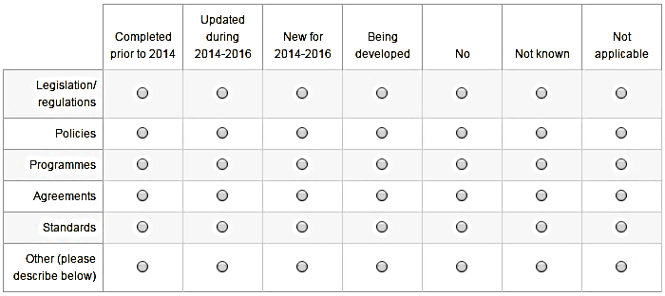

*B1.1.1 Does your government or organization have programmes in place to encourage compliance with the mechanisms identified above?

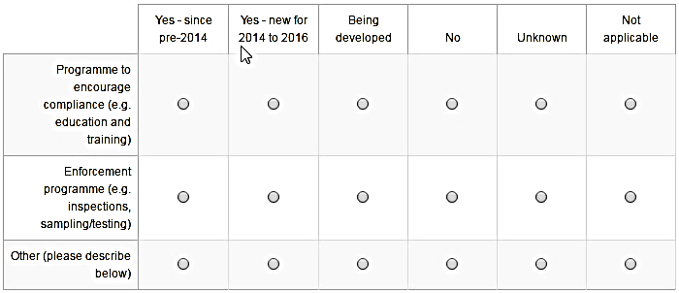

Please briefly provide additional information, including which stages of the lifecycle your mechanism(s) address (e.g. primary or secondary manufacturing, product use, recycling, end of life, etc.)?
(Maximum 2000 characters)
Please note that hazardous waste management is covered in the next section.

*B1.2 Which of the following categories or groups of chemicals does your country or organization prioritize for risk management?
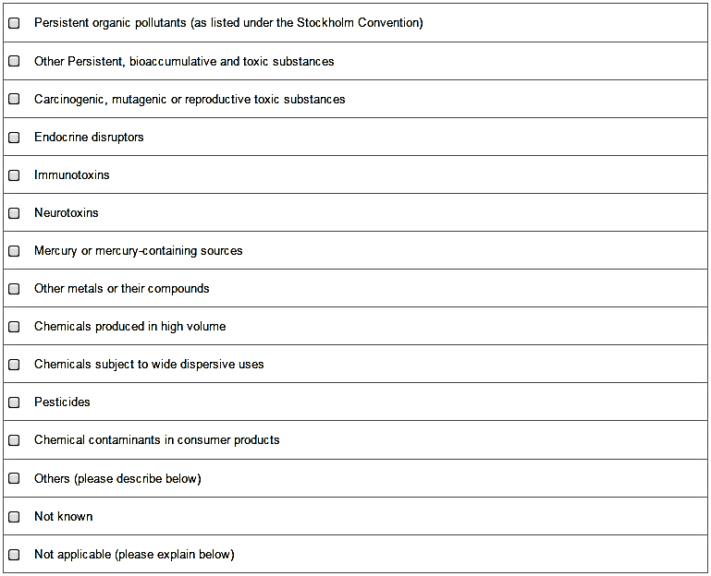

Please briefly provide additional information (e.g. other priority chemicals or categories, or reasons why this is not relevant for your country or organization).
(Maximum 1000 characters)

B2: Hazardous waste management arrangements
*B2.1 Please identify which part of the waste management cycle your government or organization addresses and the mechanism used:
Only one mechanism can be selected per part. If your government or organization uses a combination of mechanisms to address a part of the waste management cycle, please choose "Mix of tools" and describe briefly below.

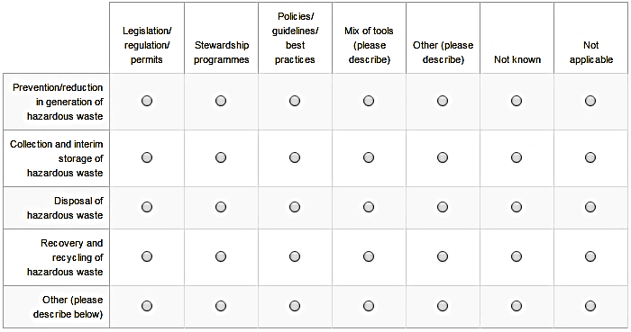

Please briefly provide any additional information you would like to share:
(Maximum 1000 characters)

*B2.2 Please indicate below whether your government or organization introduced, revised or was developing mechanisms to address parts of the waste management cycle over the 2014 to 2016 period?

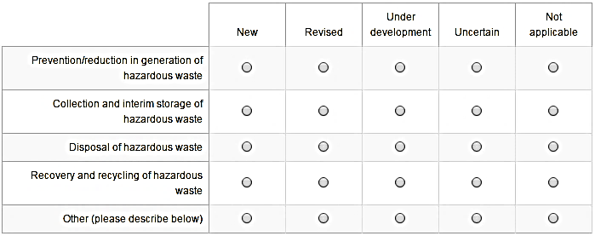

Please briefly provide any additional information you would like to share:
(Maximum 1000 characters)

B2.3 Please indicate whether your country or organization addresses any of the following specific waste streams?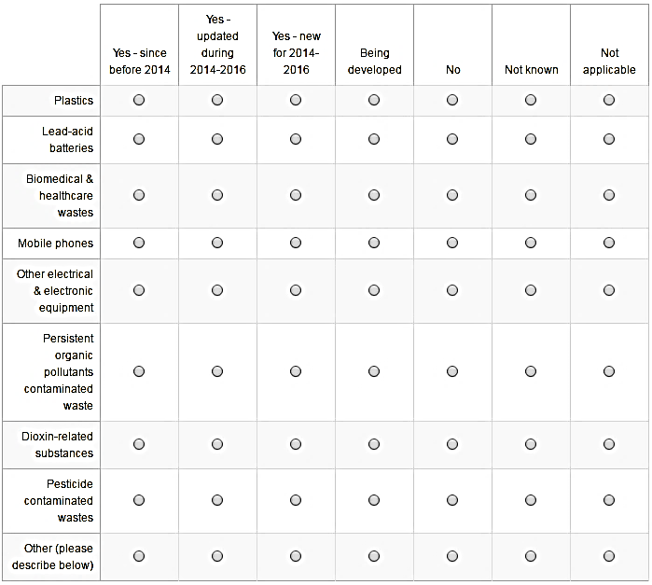

Please briefly provide additional information, including the type of tool or mechanism used to address each waste stream (legislation, permit, stewardship program, education etc.).
(Maximum 2000 characters)

B3: Mechanisms for setting priorities for risk reduction.
*B.3.1 Does your country or organization use science­based risk assessment to set priorities for risk reduction for any of the following types of chemicals?
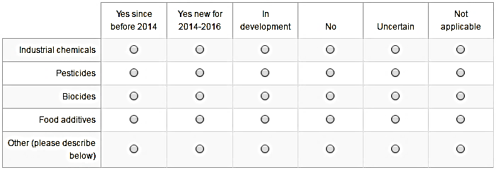
B3.1A Please specify whether the above is pre­market or post­market assessment?
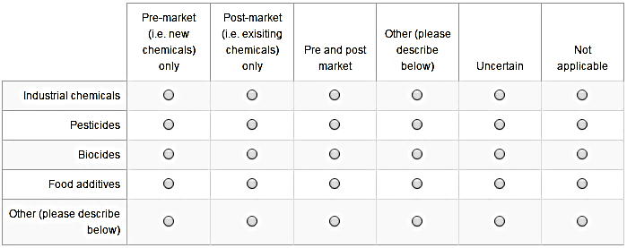
B3.1B Which of the following risks are considered as part of your government's or organization's prioritization process?
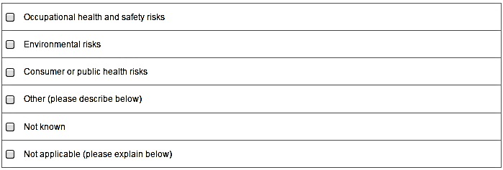
Please briefly provide any additional details you wish to share on your answers to question B3.1.
(Maximum 1000 characters)
*B3.2 Does your government or organization have programmes for the management of priority risks associated with exposures to any of the following?
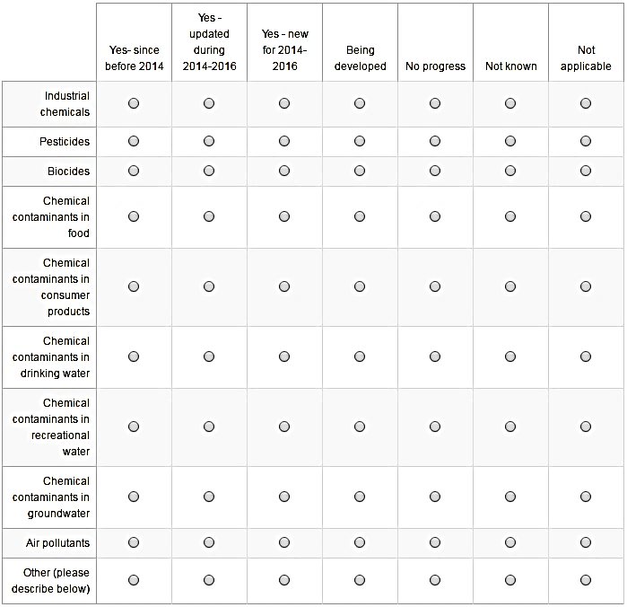
Please briefly provide any additional information you wish to share.
(Maximum 1000 characters)

*B3.3 Is there a multi­disciplinary scientific committee, body or institute engaged in your government's or organization's scientific risk assessment, prioritization, or risk reduction activities?
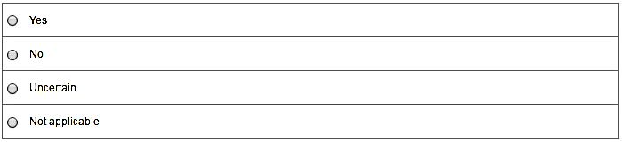
  - If “yes”: Please briefly describe your committee(s), including the name and the specific topics dealt with (Maximum 2000 characters):
B4: Use of chemicals management tools
*B4.1 Which of the following tools or guidance materials for risk reduction published by the Participating Organizations of the Inter­Organization Programme for the Sound Management of Chemicals (IOMC) are used by your government or organization?
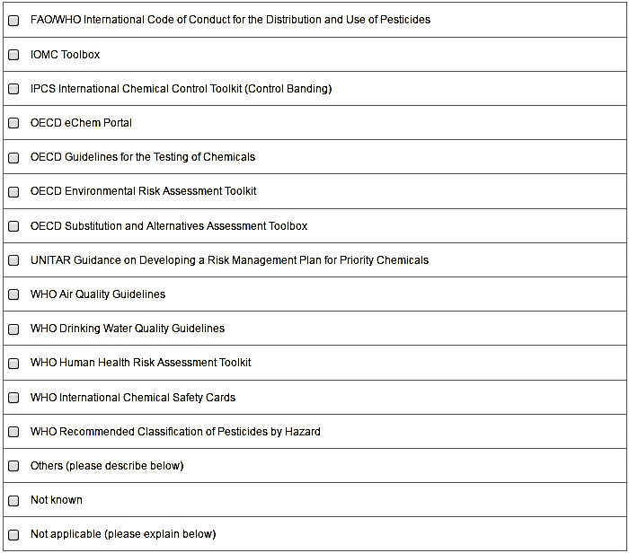

If desired, please briefly provide additional details about your response to this question.
(Maximum 1000 characters)

B4.2 Please provide the name(s) of any other (i.e. non­IOMC) tools or guidance documents your government or organization has found helpful for risk reduction activities:
(Maximum 1000 characters)

B4.3 Has your government or organization published any tools or guidance materials in the following areas:

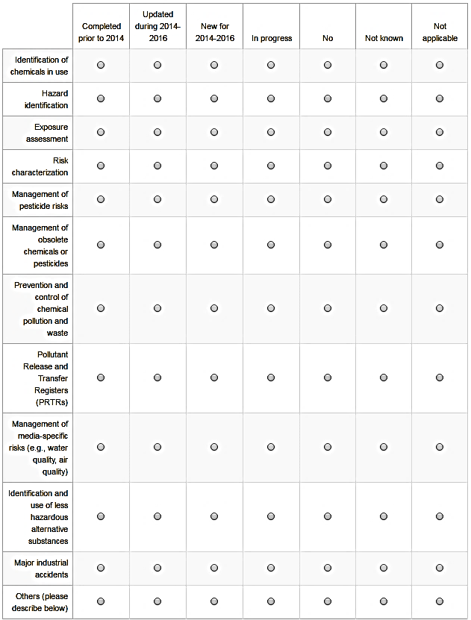

If desired, please briefly provide any additional information.
(Maximum 1000 characters)

B4.4 Please describe any additional tools or guidance materials that your government or organization would find helpful for developing or implementing risk reduction activities:
(Maximum 2000 characters)

B5: Monitoring activities for selected environmental and health priorities
*B5.1 Please identify whether your government or organization is engaged in any of the following kinds of monitoring or surveillance activities with respect to chemicals
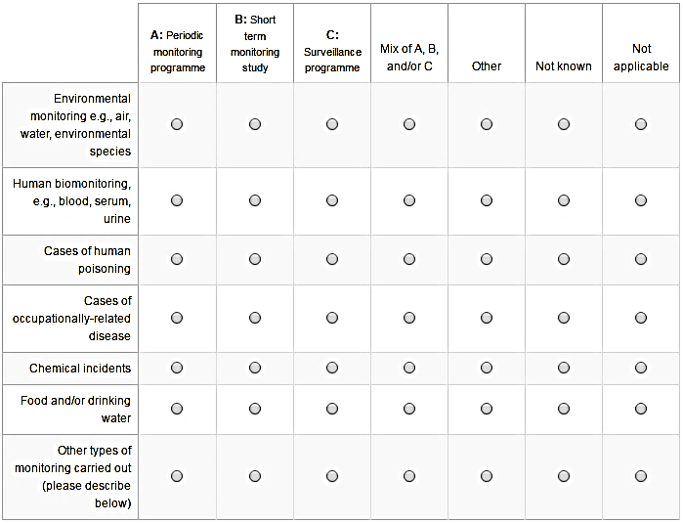
For the purpose of this survey:
In a periodic monitoring programme sampling and testing is repeated at specific intervals over a period of many years which allows for the establishment of general trends in a population or environmental matrix.
Short term monitoring would normally be related to a specific issue in a target population or location and is intended to identify or monitor specific issues, e.g., blood­lead levels in school children or pollution in a waterway following a spill.
Surveillance refers to more passive data collection, e.g., incidents of chemical poisonings (human or wildlife), chemical incidents etc.

B5.2A Please identify the sectors that are involved in the monitoring or surveillance activities you identified in question B5.1.
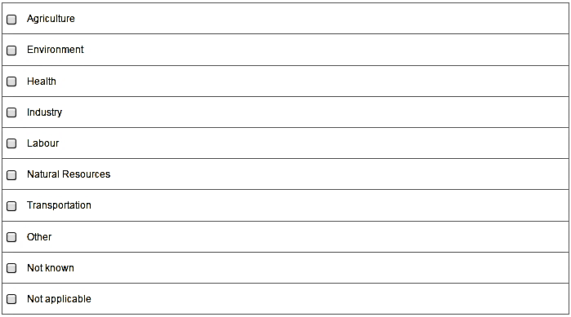
    - If “other”: Please specify the sector involved.

*B5.2B Please describe the engagement of the health sector in any of the monitoring or surveillance activities you identified in question B5.1.
(Maximum 2000 characters)

B5.3 Please indicate whether any significant changes or new developments have occurred in your country's or organization's monitoring or surveillance programmes over the period 2014­2016.
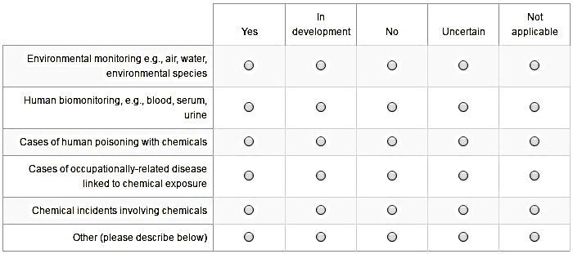

Please briefly provide any additional details you wish to share about your monitoring or surveillance programmes (Maximum 2000 characters)

*B5.4 Is your government or organization involved in any cooperative work to compare the results of monitoring or surveillance programmes?

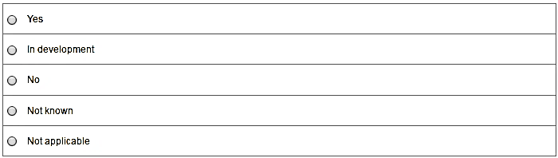

  - If “yes” or “in development”: If possible, please briefly provide more details.
(Maximum 1000 characters):

Risk Reduction ­ General
Please provide any additional information you would like to share on your government's or organization's activities relevant to the risk reduction indicators.

--- End of Part B ---

Part C: Knowledge and Information
ICCM2 selected four indicators to measure progress on the Knowledge and Information objective included in SAICM's Overarching Policy Strategy. These four indicators are:

•Provision of information according to internationally harmonized standards;
•Communication of risks to vulnerable groups;
•Research; and
•Websites providing information to stakeholders.

This part of the online survey asks questions to help evaluate progress on these four indicators.

C1: Provision of information in accordance with internationally harmonized standards

*C1.1 Do you have standards or requirements in your country or organization for labelling the hazards and/or risks posed by all chemicals at the following stages in a chemical's life­cycle?
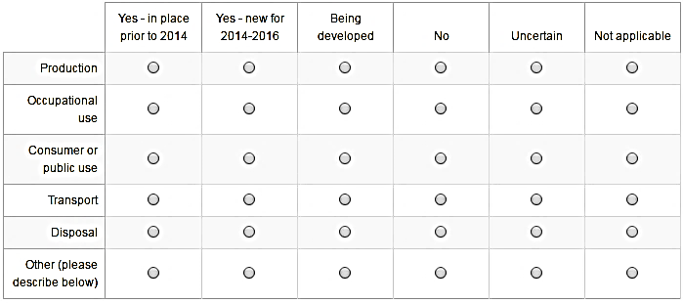

Please briefly provide any additional information you wish to share.
(Maximum 1000 characters)

*C1.2. Do the labeling requirements of your government or organization conform with those of the Globally Harmonized System for the Classification and Labelling of Chemicals (the "GHS") for the following categories?
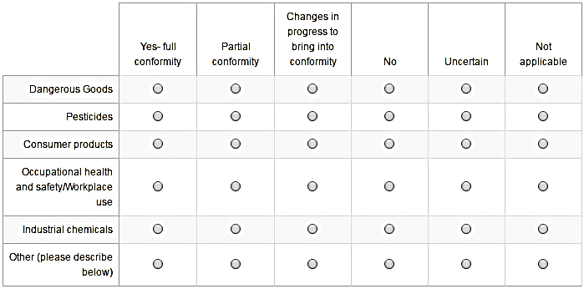

Please briefly provide any additional information you wish to share.
Maximum 1000 characters

*C1.3. Over the 2014 to 2016 period, were there any major changes in your standards or requirements for labelling the hazards and/or risks posed by chemicals with respect to conformity with the GHS?
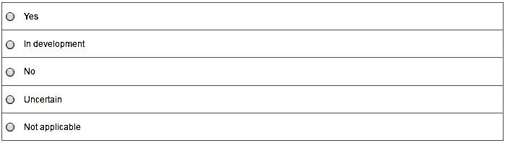

    - If “yes” or “in development” : Please briefly provide any additional information you wish to share on the changes (Maximum 1000 characters):

C2: Communication of risks to vulnerable groups
*C2.1 Does your government or organization undertake activities or publish guidance, training or awareness materials designed to communicate chemical safety issues to any of the following?
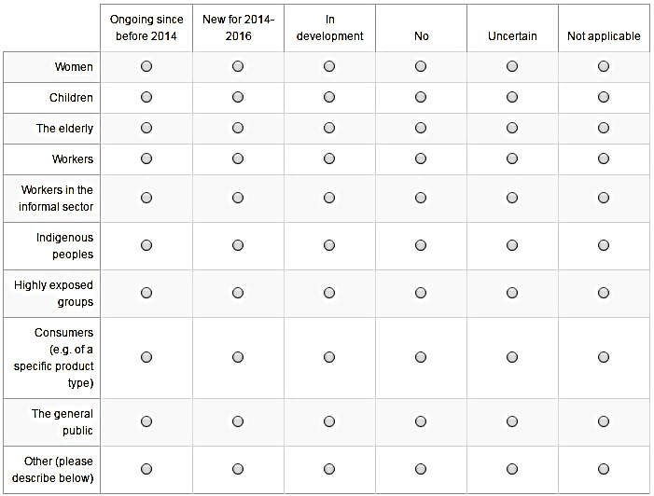

C2.2A Please identify the sectors involved in communicating about chemical safety issues with the groups identified in question C2.1.
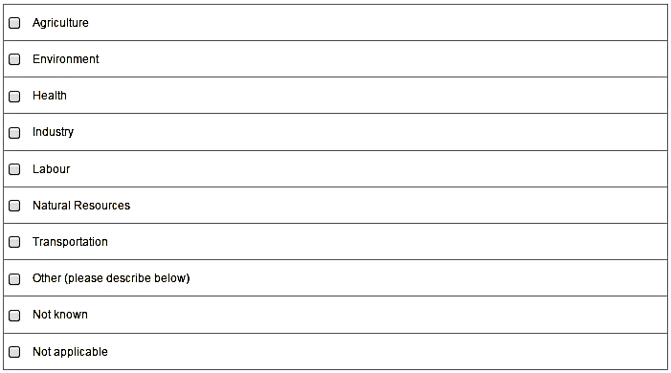
      - If “other”: Please specify the sector involved.
*C2.2B Please describe the nature of involvement by the health sector in communicating with the groups you identified in question C2.1 (Maximum 2000 characters).

Please briefly provide any additional information you wish to share about your communications with vulnerable groups (Maximum 2000 characters)

C3: Research
*C3.1 Has your country or organization commissioned or funded research in any of the following areas of chemical safety?
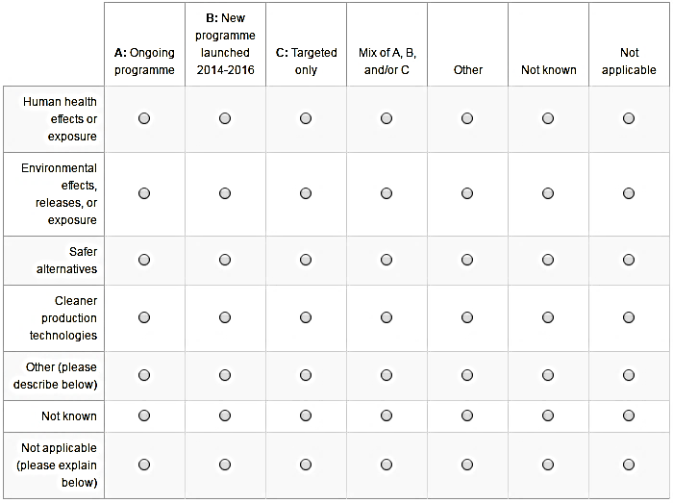

Please briefly provide any additional information you wish to share.
(Maximum 1000 characters)

C3.2A Please indicate the sectors involved in any research identified in question C3.1?

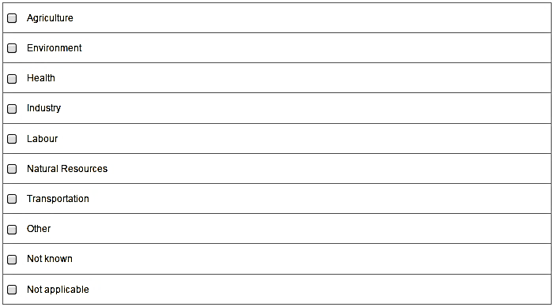

    - If “other”: Please specify the sector involved.

*C3.2B Please briefly describe the nature of involvement by any health sector institutions or professional bodies in the research you identified in question C3.1.
(Maximum 2000 characters)

C4: Websites providing information to stakeholders
*C4.1 Does your government or organization maintain any websites that provide publicly available information on any of the following topics.
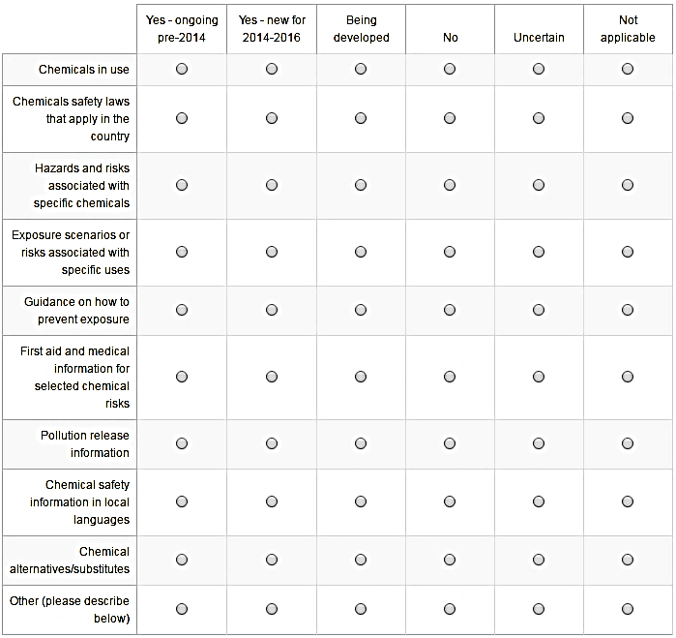

*C4.1.1 If any of the websites identified in question C4.1 are hosted by a health sector organization, please briefly describe below and provide web links.
(Maximum 2000 characters)

C4.2 Please indicate whether the overall amount of chemical safety information you make publicly available through websites has increased, decreased or remained the same over the 2014 to 2016 period:

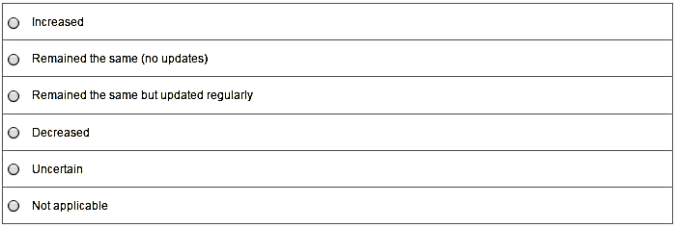

Please briefly provide any additional information you wish to share on the provision of information to stakeholders through websites (including web links).
(Maximum 1000 characters)

C4.3 Have you used other channels of public information (e.g., social media (Twitter, Facebook etc.), printed media, television, radio, or community workers) between 2014 and 2016 to communicate on chemicals safety related topics?

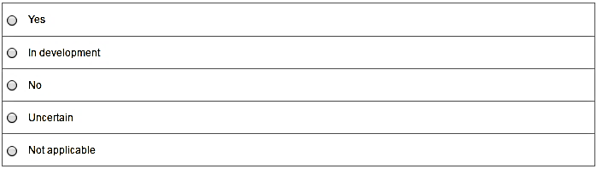

  - If “Yes” or “In development”: Please briefly provide any additional information you wish to share (Maximum 1000 characters)

Knowledge and Information ­ General
Please provide any additional information you would like to share on your government's or organization's activities relevant to the Knowledge and Information indicators.

--- End of Part C ---
Part D: Governance
ICCM2 selected three indicators to measure progress on the Governance objective included in SAICM's Overarching Policy Strategy. These three indicators are:
•Commitments to implementation of the Strategic Approach;
•Multi­stakeholder coordination; and
•Implementation of key international chemicals agreements.
This part of the online survey asks questions to help evaluate progress on these three indicators.

D1: Commitments to implementation of the Strategic Approach
*D1.1 Please identify how your government or organization has demonstrated its commitment to SAICM implementation over the 2014 to 2016 period:
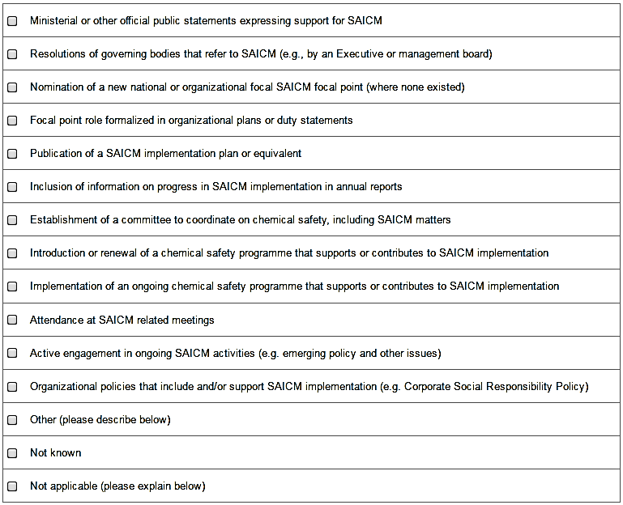

Please briefly provide any additional information you wish to share.
(Maximum 1000 characters)

D2: Multi­stakeholder coordination

Government:*D2.1 Please indicate if your government has a national multi­stakeholder or multi­sectoral committee designed to broadly address (make decisions or provide advice on) chemical safety issues, including SAICM:
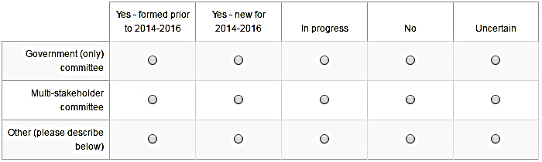

    - If “Yes” indicated for “Government (only) committee”:
*D2.1.1A Please identify which ministries are represented on your government only committee.
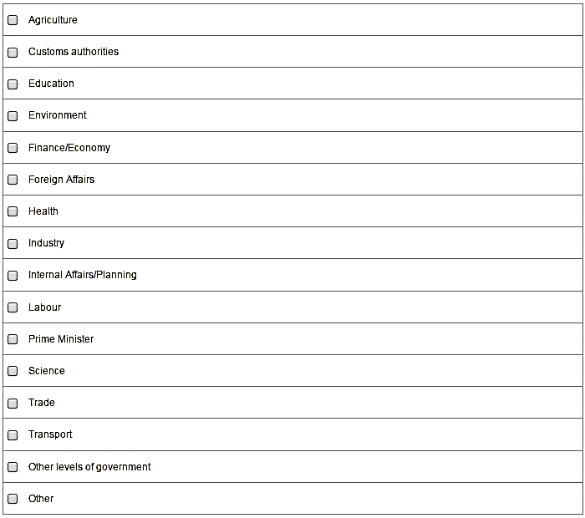

Stakeholders other than governments: *D2.1 Please indicate whether your organization coordinates or is engaged in any multi­stakeholder or multi­sectoral committees (not including ICCM) designed to broadly address (make decisions or provide advice on) chemical safety issues, including SAICM:

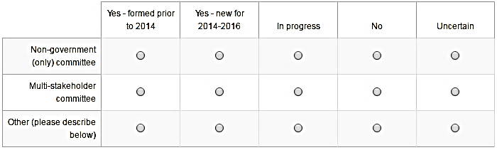

    - If “Yes” indicated for “Non-government (only) committee”:
*D2.1.1 Please identify the types of stakeholders on your non-governmental committee.
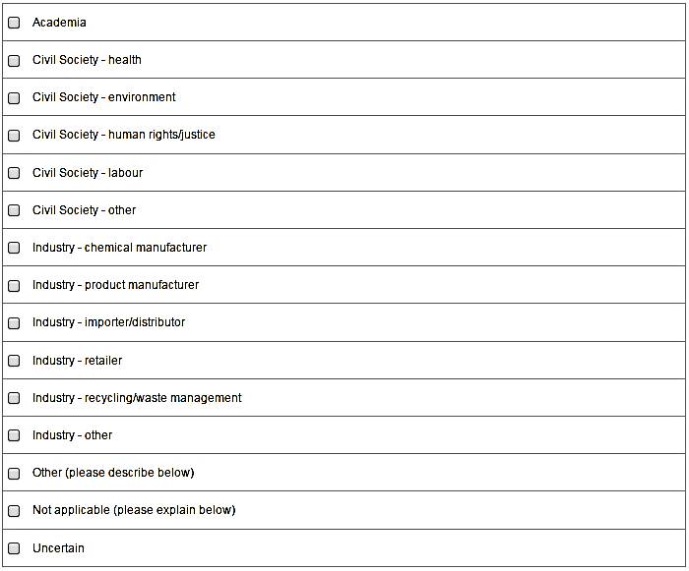

All stakeholders:
    - If “yes” indicated for “multi-stakeholder committee”:
*D2.1.2 (a) Please identify the types of stakeholders included on your multi­stakeholder committee.
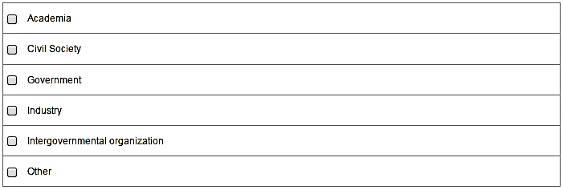
*D2.1.2 (b) Please identify the interests represented on your multi­stakeholder committee.
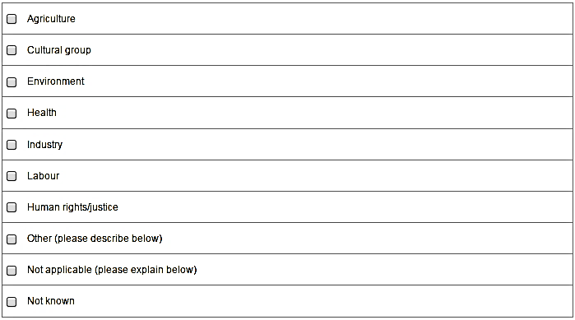

  - If “yes” indicated for “Other Committee”:
*D2.1.3 Please briefly describe your "Other" committee (Maximum 1500 characters)

  - If “Others” has been selected in response to any of the questions in D2.1: *Please briefly indicate which "Others" are represented on your committee (Maximum 1000 characters).

Please briefly provide any additional information you wish to share.
Maximum 1000 characters

*D2.2 In 2012, the International Conference on Chemicals Management adopted a strategy for strengthening the engagement of the health sector in chemicals management. Please briefly describe in the space that follows any activities undertaken by your government or organization over the 2014­2016 period to support implementation of this strategy.

D3: Implementation of key international chemicals agreements
*D3.1 Were any significant changes made to your country's or organization's status and/or implementation with regard to the following international or regional chemicals instruments over the 2014 to 2016 period (e.g. through the enacting of legislation, programme implementation, or through relevant policies)?

Acronyms
FAO ­ Food and Agriculture Organization ILO ­ International Labour Organization IMO ­ International Maritime Organization
OECD ­ Organisation for Economic Co­operation and Development OPCW ­ Organisation for the Prohibition of Chemical Weapons UNECE ­ United Nations Economic Commission for Europe
UNEP ­ United Nations Environment programme

Note: The WHO Secretariat will provide information directly to the SAICM Secretariat regarding implementation of the International Health Regulations (2005).

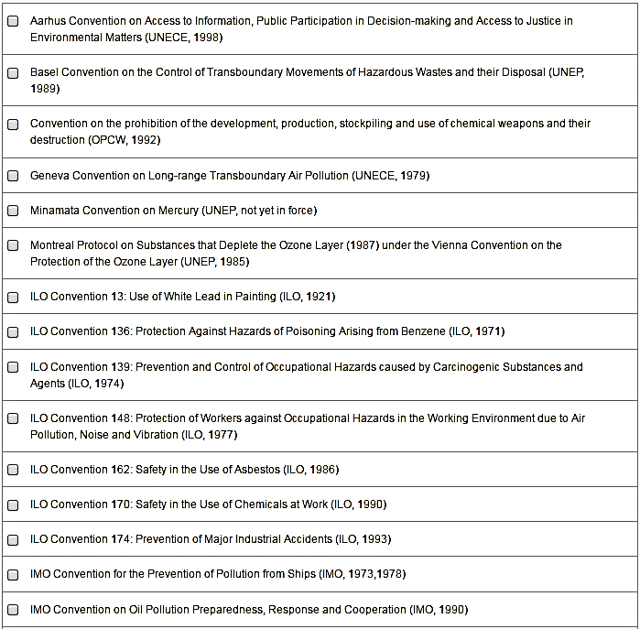

D3.1 Continued

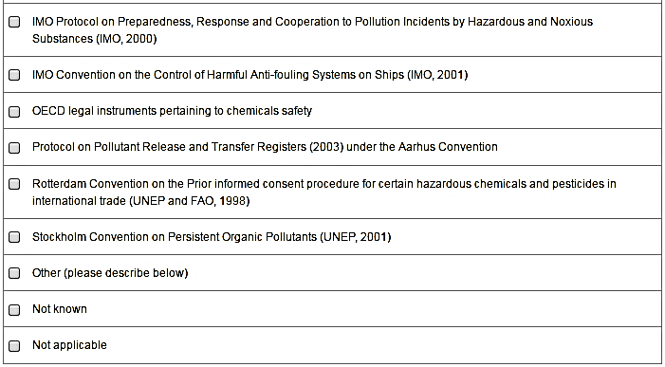

D3.1.1 Please briefly describe any changes identified in question D3.1 and briefly describe the outcome with regards to implementation of the instrument(s).
(Maximum 2000 characters)

D3.2 Please briefly provide any additional information on how your government or organization is engaged in implementing or supporting key international agreements relevant for chemicals and waste.
(Maximum 2000 characters)

Governance ­ General

4.4.1 Please briefly provide any additional information you would like to share on your government's or organization's activities relevant to the Governance indicators.

--- End of Part D ---

Part E: Capacity­building and technical cooperation
ICCM2 selected six indicators to measure progress on the Capacity-building and technical cooperation objective included in SAICM's Overarching Policy Strategy, including one indicator on SAICM's Quick Start Programme Trust Fund(QSP). Information on the QSP indicator will be compiled from sources held by the secretariat.
The five remaining indicators relevant to this part of the survey are:
- Financial and in­kind resources to assist capacity­building and technical cooperation;
- Identification and prioritization of capacity­building needs;
- Regional cooperation on sound chemicals management;
- Development assistance programmes that include sound chemicals management; and
- Other sources of funding for capacity­building.

*Self­identification
The relevance of many of the indicators for this objective depends on whether a country or organization is primarily a donor or a recipient of capacity building assistance. Therefore, the questions asked in this part will be based on your self­identification as either a donor or recipient. If you prefer to have the opportunity to answer all the questions, simply select "both".

Donor country or organization
Recipient country or organization
Both (donor and recipient)

E1: Financial and in­kind resources to assist capacity­building and technical cooperation (Donors)
*E1.1D Please indicate whether your government or organization provided financial or in­kind assistance over the 2014 to 2016 period to improve capacity for the sound management of chemicals in developing countries or countries in transition?
If applicable and possible, please also indicate how this compares to assistance provided in the last reporting period (2011 to 2013).
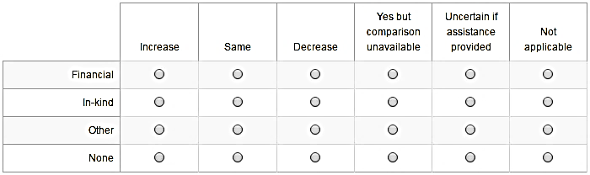

E1.1.1D If possible and applicable, please indicate which government department(s) provided the financial or in­kind assistance identified in question E1.1.
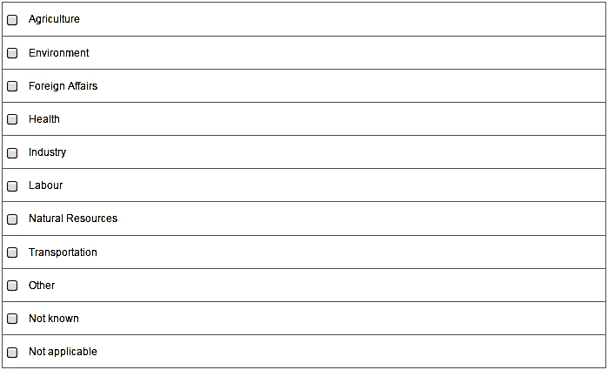

Please briefly provide any additional information you wish to share about assistance provided by your country or organization (Maximum 2000 characters).

E2: Identification and prioritization of capacity­building needs (Recipients)
*E2.1R Which of the following types of plans, relevant for identifying capacity building needs for chemicals management, has your government or organization completed?
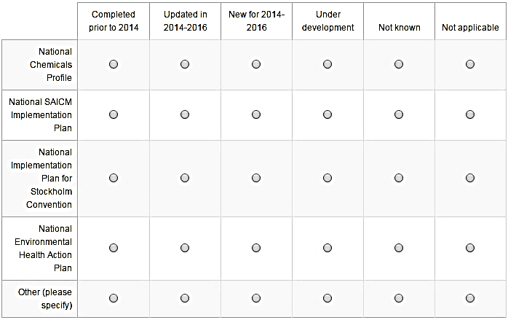
E2.2R If possible, please select the priority needs you have identified from the list below (based on the 11 basic elements from the Orientation and Guidance Document):
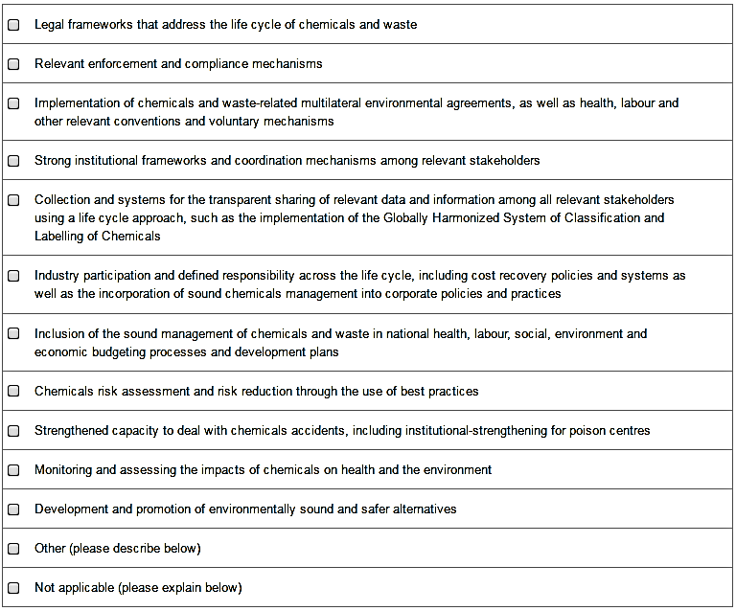

Please briefly provide any additional information or comments you wish to share on the identification and prioritization of capacity­building needs (Maximum 2000 characters).

E3: Development assistance programmes that include sound chemicals management

Donors: *E3.1D Did your country include chemicals management as a priority in national development assistance funding programmes over the 2014 to 2016 period?

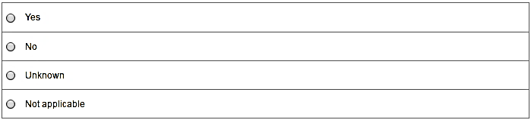
  - If “yes”: If possible, please provide the name of the programme and a web link for more information.
Recipients: *E3.1R Did your country have a national development plan covering the years between 2014 and 2016 and addressing priority needs for the sound management of chemicals?
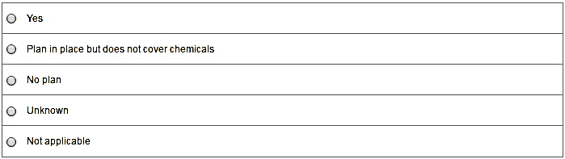
    - If “Yes”: Please provide the name(s) of the relevant development plan(s) in the space below and provide a web link if possible.

Please briefly provide any additional information or comments you wish to share relevant to the inclusion of chemicals management in development assistance programmes (Maximum 2000 characters).

E4: Other sources of funding for capacity­building (Recipients)
*E4.1 Have any of the following sources provided financial support for capacity­building activities for the sound management of chemicals in your country or organization between 2014 and 2016?
Please consider this question as broadly as possible if the activity contributes to improving the sound management of chemicals, even if the chemicals related activities may be only a small part of a project.
Note: The secretariat will use its own records to provide comparative data on funding under the SAICM Quick Start Programme (QSP) so there is no need to identify this source of funding.
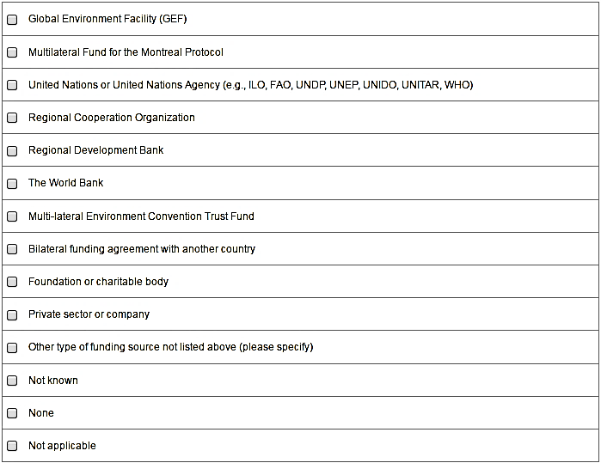
Please briefly provide any additional details below, including the name of the organization or agency that provided the funding. (Maximum 2000 characters).

E5: Regional cooperation on sound chemicals management

*E5.1 Please indicate whether your government or organization has been engaged in regional cooperative work in any of the following subject areas over the 2014 to 2016 period?

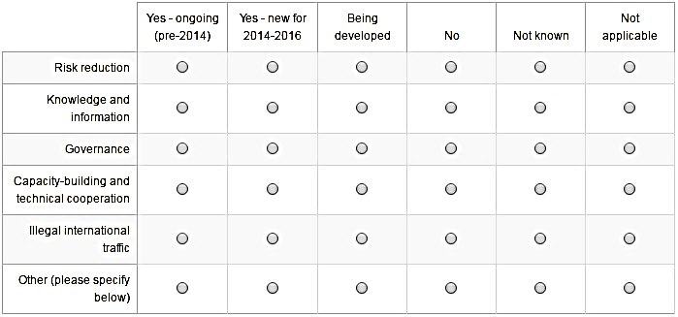

Please briefly provide any additional information or comments you wish to share on regional cooperation on sound chemicals management (Maximum 2000 characters)
.

Capacity­building and technical cooperation ­ General
Please briefly provide any additional information or comments you would like to share on your government's or organization's activities relevant to the capacity­building and technical cooperation indicators.

--- End of Part E ---
Part F: Illegal international traffic
ICCM2 selected two indicators to measure progress on the Governance objective included in SAICM's Overarching Policy Strategy, as follows:
•Illegal traffic in toxic, hazardous and severely restricted chemicals; and
•Illegal traffic in hazardous waste.
This sixth and final part of the survey asks questions relevant to these two indicators.

F1: Illegal traffic in toxic, hazardous and severely restricted chemicals
*F1.1. Which of the following activities in support of preventing illegal international traffic of hazardous chemicals are in place in your country or organization?
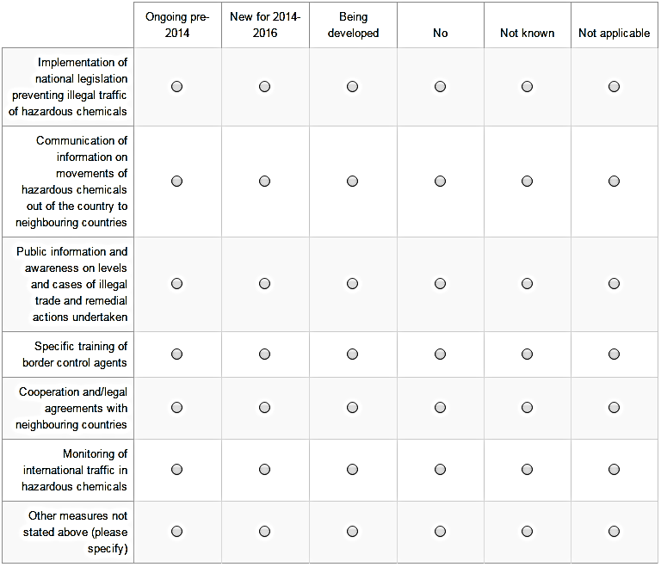

Please briefly provide any additional information you wish to share
(Maximum 1000 characters)

F2: Illegal international traffic of hazardous waste
*F2.1 Which of the following activities in support of preventing illegal international trade in hazardous waste are in place in your country or organization?
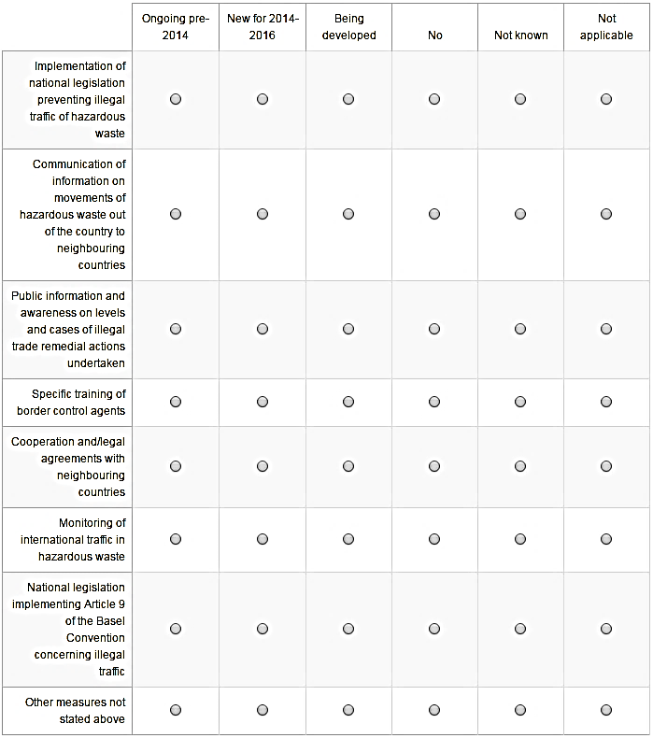

Please briefly provide any additional information you wish to share.
Maximum 1000 characters

Illegal international traffic ­ General
Please briefly provide any additional information or comments you would like to share on your government's or organization's activities relevant to the indicators for illegal international traffic.

End of Survey

You have reached the end of this survey. Your participation will help to ensure that the third SAICM report on progress is accurate and complete so it can be used to measure progress in SAICM over the 2014 to 2016 period. It will also contribute useful information to assist in setting future priorities for the global sound management of chemicals and waste.

As a reminder:

- Your link to this survey is unique and can only be used to submit one survey response. You are requested to consult as necessary and appropriate, and provide a single consolidated response for your country or organization.
- You can save the survey at different points and resume completion at any time before the deadline.
- Once you click submit, you will be given the opportunity to print your survey response but you will not be able to access the survey again.

Thank you for participating.

*Do you consent to your government or organization's response being made publicly available on the SAICM website?

Please choose only one of the following:

Yes
Yes ­ check box answers only (not comments)
No

__________

